

MANGU 2025 KCSE PREDICTION
CONFIDENTIAL EXAM
231/2
BIOLOGY
PAPER 2 (THEORY)
TIME: 2 HOURS

NAME……………………………………………………………………………………….
SCHOOL……………………………………………… SIGN………………………..
INDEX NO……………………………………………. ADM NO……………………

(Kenya Certificate of Secondary Education)

INSTRUCTIONS TO CANDIDATES
- Write your name and Admission Number in the spaces provided above.
- Sign and write the date of examination in the spaces provided above.
- This paper consists of two sections: A and B. Answer ALL questions in section A in the spaces provided. In section B, answer question 6 (compulsory) and either question 7 or 8 in the spaces provided after question 8.

FOR EXAMINERS’ USE ONLY
Section | Questions | Maximum Score | Candidate’s Score
A |  | 8
 |  | 8
 |  | 8
 |  | 8
 |  | 8
B |  | 20
 | - /8 | 20
Total Score |  | 80

SECTION A (40 MARKS)
Answer all questions in this section in the spaces provided.
1. In certain breeds of rats, a pure breeding of black rat was crossed with a pure breeding
white rat. The offspring had a coat with white and black strands that appeared grey
in colour.
a) Using letter B to represent the gene for black coat colour and W to represent the gene
for white coat colour, work out the genotypic ratio of F2 generation (5 mks)
…………………………………………………………………………………………………………
…………………………………………………………………………………………………………
…………………………………………………………………………………………………………
…………………………………………………………………………………………………………
…………………………………………………………………………………………………………
…………………………………………………………………………………………………………
…………………………………………………………………………………………………………
…………………………………………………………………………………………………………
…………………………………………………………………………………………………………
…………………………………………………………………………………………………………
…………………………………………………………………………………………………………

b) Give one example in human beings where genes behave the same as described in (a) above
(1 mk)
…………………………………………………………………………………………………………

c)(i) What is polyploidy (1 mk)
…………………………………………………………………………………………………………
…………………………………………………………………………………………………………
…………………………………………………………………………………………………………

(ii) Give one advantage of polyploidy in organisms (1 mks)
…………………………………………………………………………………………………………
…………………………………………………………………………………………………………

- In a practical investigation a raw potato was peeled, mashed into a fine paste and was treated as shown in the set-up below
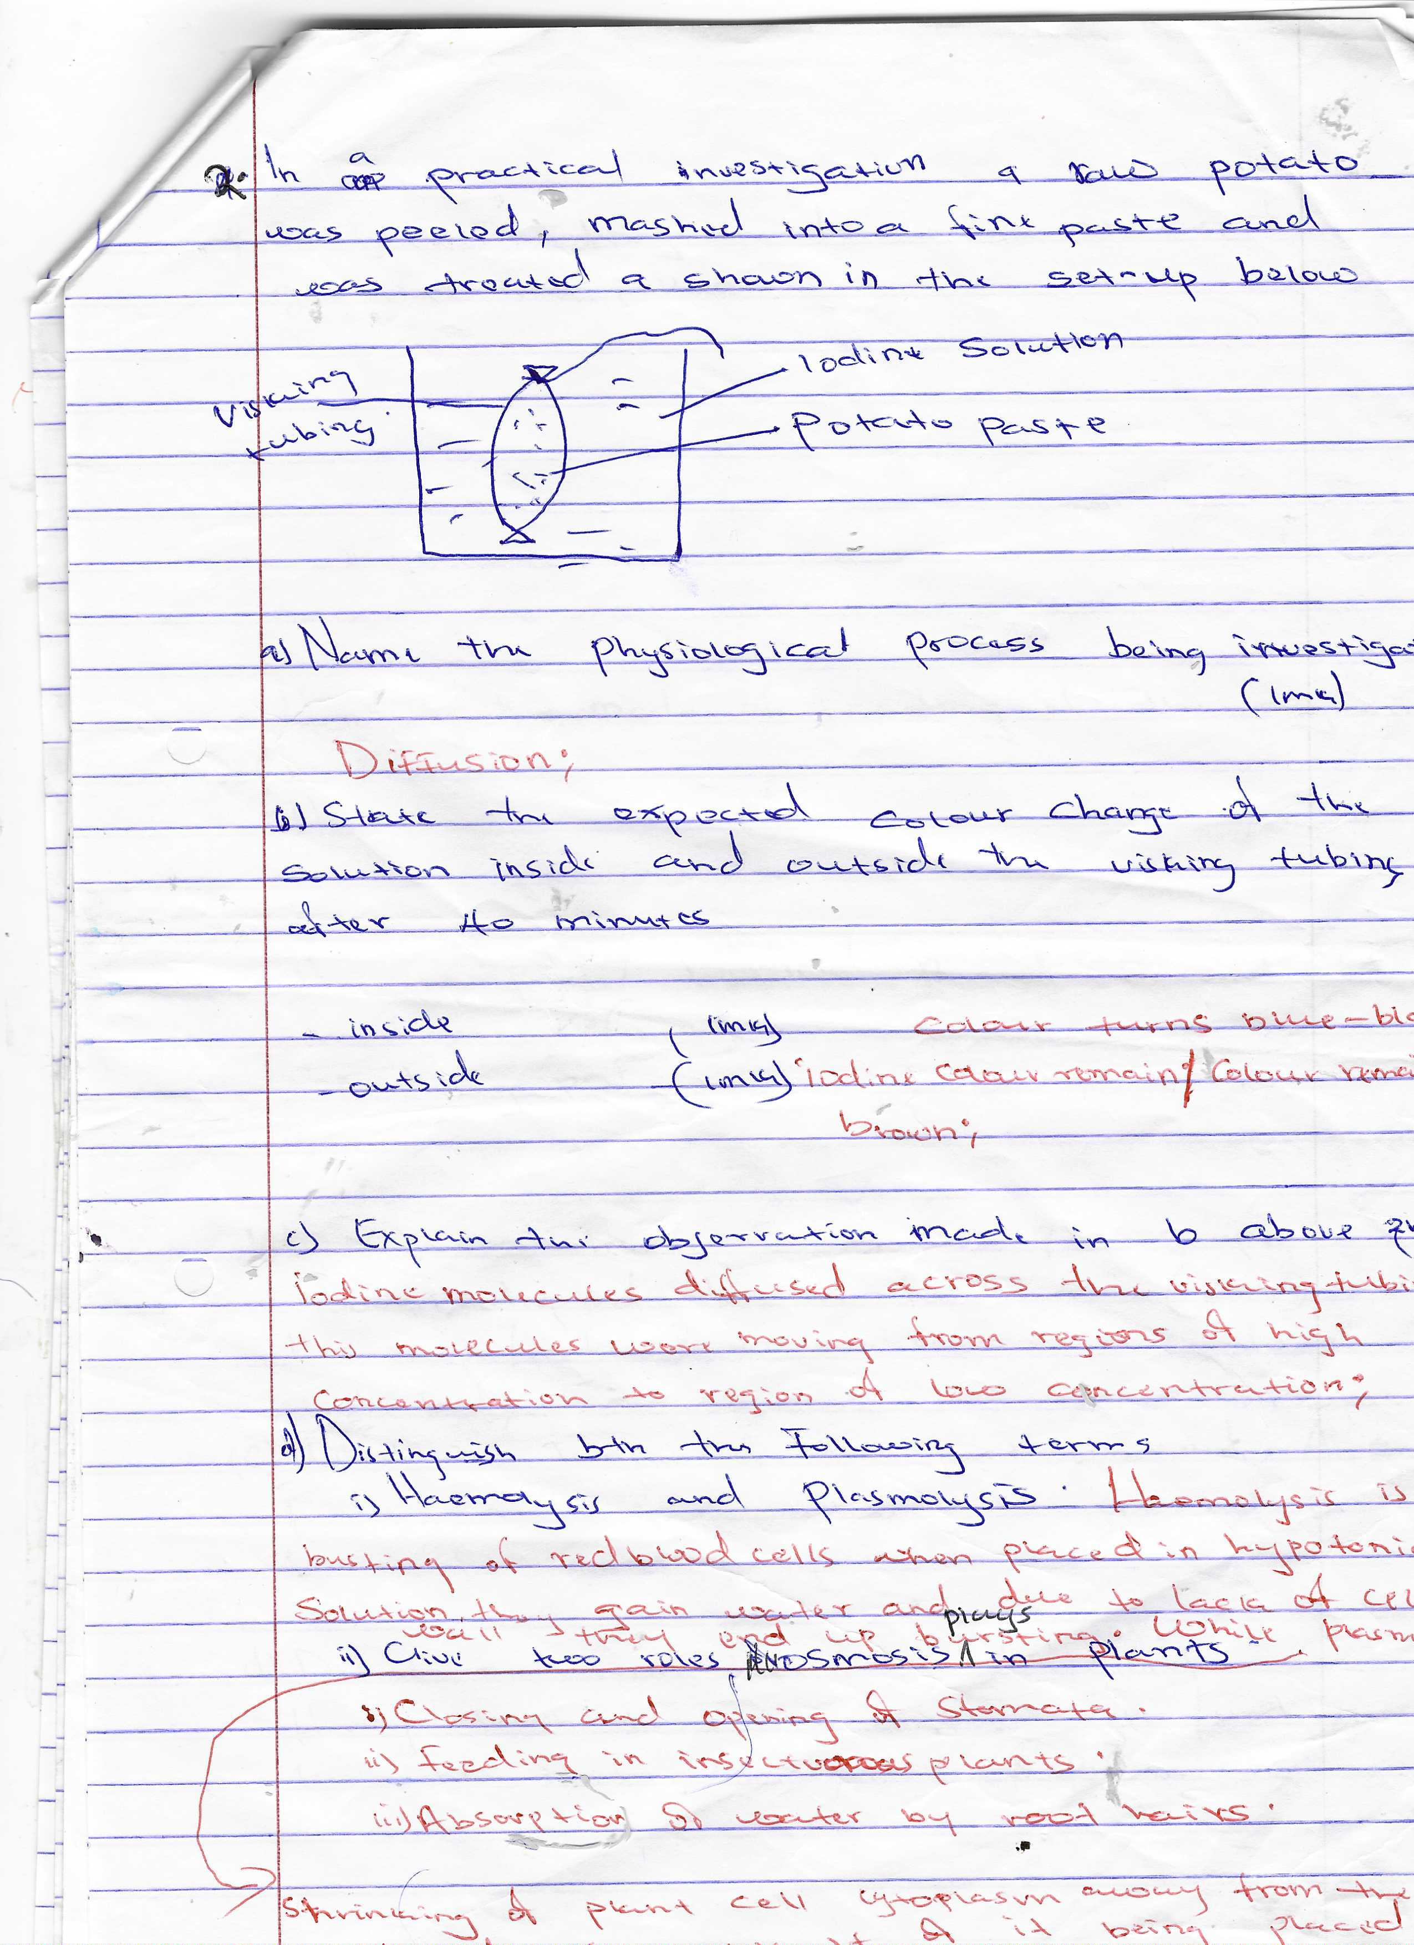
- Name the physiological process being investigated (1 mk)
…………………………………………………………………………………………………………

b)State the expected colour change of the solution inside and outside the visking
tubing after 40 minutes
inside…………………………………………………………..………….….. (1 mk)
outside………………………………………………………………………… (1 mk)

c)Explain the observation made in (b) above (2 mks)
…………………………………………………………………………………………………………
…………………………………………………………………………………………………………
…………………………………………………………………………………………………………

d) Distinguish between the following terms
i) Haemolysis and plasmolysis (2 mks)
…………………………………………………………………………………………………………
…………………………………………………………………………………………………………
…………………………………………………………………………………………………………
…………………………………………………………………………………………………………

ii) Give the role osmosis in plants (1 mk)
…………………………………………………………………………………………………………
3. The diagram below represents the nitrogen cycle. Study it and answer the questions that follow.
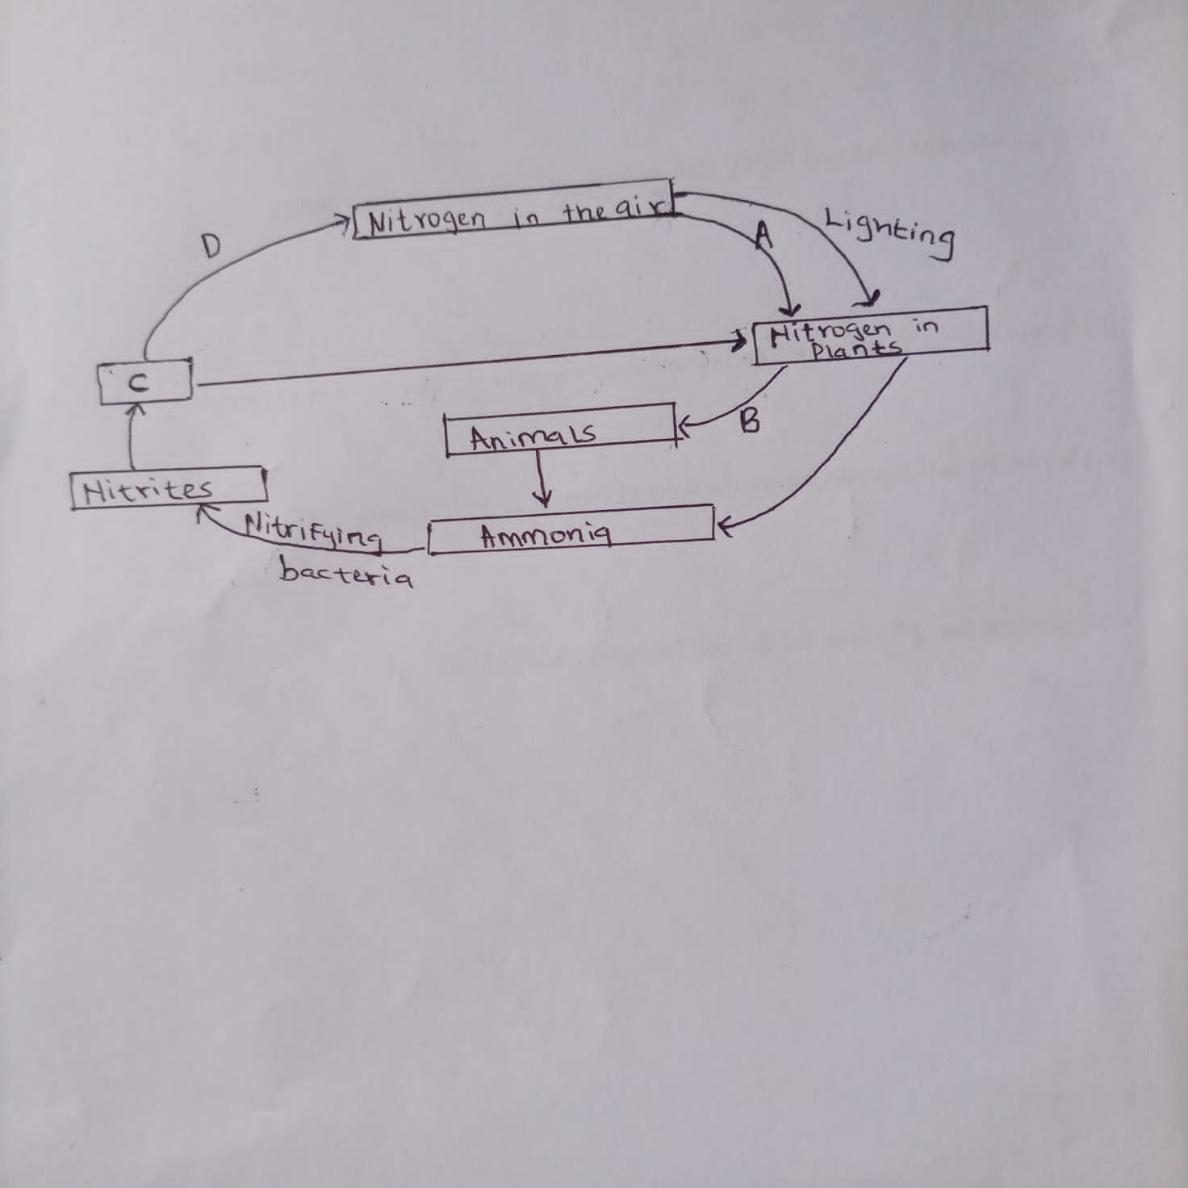
(a) Name the process represented by B. (1 mk)
…………………………………………………………………………………………………………
(b) Identify organisms responsible for;
i) process A ………………………………………………………………….. (1 mk)
ii) process D ……………………………………………………………………. (1 mk)
(iii) Name the compound represented by C. (1 mk)
…………………………………………………………………………………………………………

(c) Name the method of population estimation in the following;
(i) When studying the population of fish in a dam. (1mk)
…………………………………………………………………………………………………………
(ii) When studying cabbages in one acre of land. (1mk)
…………………………………………………………………………………………………………

(d) Name two waterborne diseases and causative agents that affect human beings from kingdom
Monera. (2mks)
Disease | Causative agent

4. Study the diagram below and answer the question that follow
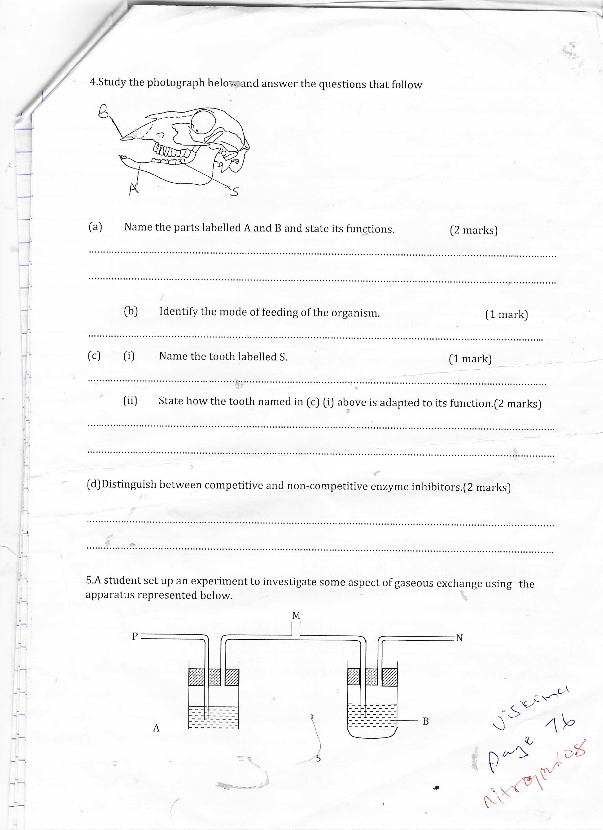
a)(i) Identify the mode of feeding of the organism. (1 mk)
…………………………………………………………………………………………………………

(ii) Name the parts labelled A and B . (2 mks)
…………………………………………………………………………………………………………
…………………………………………………………………………………………………………

- How is the tooth S in the photograph above adapted for its functions (1 mk)
…………………………………………………………………………………………………………
…………………………………………………………………………………………………………

- What are the functions of the part labelled A. (2 mks)
…………………………………………………………………………………………………………
…………………………………………………………………………………………………………
…………………………………………………………………………………………………………

- Distinguish between the terms homodont and heterodont (2 mks)
…………………………………………………………………………………………………………
…………………………………………………………………………………………………………
…………………………………………………………………………………………………………
…………………………………………………………………………………………………………

5. The diagram below represents a transverse section through a plant organ
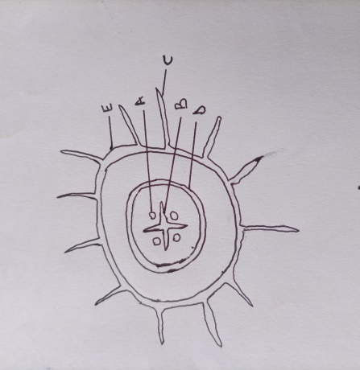
- (i) From which organ was the section obtained (1 mk)
…………………………………………………………………………………………………………
(ii) Give two reasons for your answer in (a) above (2 mks)
…………………………………………………………………………………………………………
…………………………………………………………………………………………………………
…………………………………………………………………………………………………………

- How is part C adapted to its functions (2 mks)
…………………………………………………………………………………………………………
…………………………………………………………………………………………………………
…………………………………………………………………………………………………………
…………………………………………………………………………………………………………

- State two structural differences between an arteries and veins (2 mks)
…………………………………………………………………………………………………………
…………………………………………………………………………………………………………
…………………………………………………………………………………………………………
…………………………………………………………………………………………………………

- Give one defect that affect the arteries in human beings (1 mk)
…………………………………………………………………………………………………………

SECTION B(40 MARKS
Answer question 6 (compulsory) and either question 7 or 8
6. Two sets of bean seeds were germinated, set A was placed in normal daylight condition in the laboratory while set B was placed in a dark cupboard. After a few days later the shoots were measured twice daily and their mean lengths recorded as shown in the table below.

Time in hours | 0 | 12 | 24 | 36 | 48 | 60 | 72 | 84
Set A length (mm) | 13 | 15 | 21 | 24 | 29 | 32 | 48 | 55
Set B length (mm) | 18 | 24 | 29 | 36 | 49 | 63 | 81 | 95

(a) Using a suitable scale draw the graphs of the mean lengths in set A and B against time (8 mks)

b) From the graph state the mean shoot length of each set of seedlings at
the 54th hour (1 mk)
…………………………………………………………………………………………………………
c)Account for the difference of curve B and A . (3mks)
…………………………………………………………………………………………………………
…………………………………………………………………………………………………………
…………………………………………………………………………………………………………
…………………………………………………………………………………………………………

d)Explain what would happen to set-up B if it were allowed to continue to grow under condition of darkness. (4mks)
…………………………………………………………………………………………………………
…………………………………………………………………………………………………………
…………………………………………………………………………………………………………
…………………………………………………………………………………………………………
…………………………………………………………………………………………………………

e) State three external conditions which should be constant for both set-ups (3 mks)
…………………………………………………………………………………………………………
…………………………………………………………………………………………………………
…………………………………………………………………………………………………………

(f) Give one survival value of phototropism in plants. (1 mk)
…………………………………………………………………………………………………………

7.(a)Giving relevant examples,explain how seeds and fruits are adapted to animal Dispersal (6 mks)
b)Describe the process of double fertilization in flowering plants (14 mks)

8(a) Distinguish between excretion and secretion (2 mks)
b) Explain the main homeostatic function of the mammalian liver (18 mks)

